

|  |
| --- |
| **Network Assessment & Penetration Test**  **David Cox**  CMP314: Computer Networking 2  **BSc Ethical Hacking Year 3**  2023/24 |

*Note that Information contained in this document is for educational purposes.*

Contents

1 Introduction 1

1.1 Background 1

1.2 Aims 1

2 Network Diagrams 2

2.1 Network Topology 2

2.2 Routing Table 3

2.3 Subnet Table 4

3 Networking Mapping Process 6

3.1 Original Scans 6

3.2 192.168.0.193 8

3.2.1 172.16.221.0/24 10

3.3 192.168.0.210 13

3.4 192.168.0.226 16

3.4.1 192.168.0.34/27 17

3.4.2 192.168.0.229/30 23

3.5 192.168.0.230 25

3.5.1 192.168.0.128/27 25

3.5.2 192.168.0.240/30 28

3.5.3 192.168.0.98/27 34

3.6 192.168.0.97 36

3.6.1 192.168.0.64/27 37

4 Security Weaknesses 42

4.1 Default Passwords 42

4.2 Lack of Password Policy 42

4.3 Password Reuse 42

4.4 Shellshock (CVE-2014-6271) 43

4.5 Lack of Telnet Encryption 43

4.6 Lack of HTTPS 43

4.7 Unprotected Fileshares 44

4.8 Outdated Web Service Versions 44

4.9 Lack of SSH Bruteforce Protection 44

4.10 Network Topology 45

5 Network Design Critical Evaluation 47

6 Conclusions 48

7 Bibliography 49

Appendices 51

7.1 Subnet Table Calculations 51

7.1.1 Subnet Calculations 51

7.1.2 13.13.13.0/24 & 172.16.221.0/24 51

7.1.3 192.168.0.*/27 51

7.1.4 192.168.0.*/30 52

7.2 Valid Host Range for the 255.255.255.224 subnet 52

7.3 Dirb Output for 172.16.221.237 53

7.4 WPScan Output for 172.16.221.237 58

# Introduction

## Background

Computer networks are a part of every person’s day to day life in some regard or another, which also means that the security of the computer networks that are used in our day-to-day life is crucial to keep our lives operating smoothly and prevent from any knock-on effects that could bring businesses and consumers to a halt. Despite the fact that it is a hard job to maintain a computer network, it remains crucially important to stay on top of security issues within a network, as well as having a thorough understanding of the network and all of the components that are used to create it.

The tester has been approached by a company, ACME Inc. who have recently parted ways with their network manager who, in the tester’s brief, was said to have parted ways with the company due to “acrimonious circumstances”. After parting ways with the network manager, ACME Inc attempted to review any documents left by the manager to review and assess the status of their network, although they were unable to find any documentation that had been produced which has caused management to become worried about the security and overall status of their network and as such, reached out to the tester.

The tester has been asked to evaluate the security of the ACME Inc network through the use of a Kali Linux virtual machine provided by the company. The tester was also asked to only use the tools provided on the machine to ensure that any tools used were stable and would not cause any potential further harm to the network.

## Aims

The aims of this report are to create a detailed network diagram that shows all of the devices on the client’s network, create a routing table that identifies all IP addresses, subnets, broadcast addresses and netmasks. Finally, the tester has been asked to conduct a penetration test against the network to find any vulnerabilities or weaknesses on any devices present on the network, as well as the steps needed from the client to remediate any issues.

# Network Diagrams

## Network Topology

To effectively create a network topology diagram, the tester utilised the “Nmap” package which was installed on their Kali Linux machine to scan each device that they came across throughout their test of the network. This tool allowed the tester to identify key information about each device including its IP address, subnet mask, broadcast address and list of active services running on the devices. The tester has shown the output from their Nmap scans throughout section 3, titled, “Networking Mapping Process”.

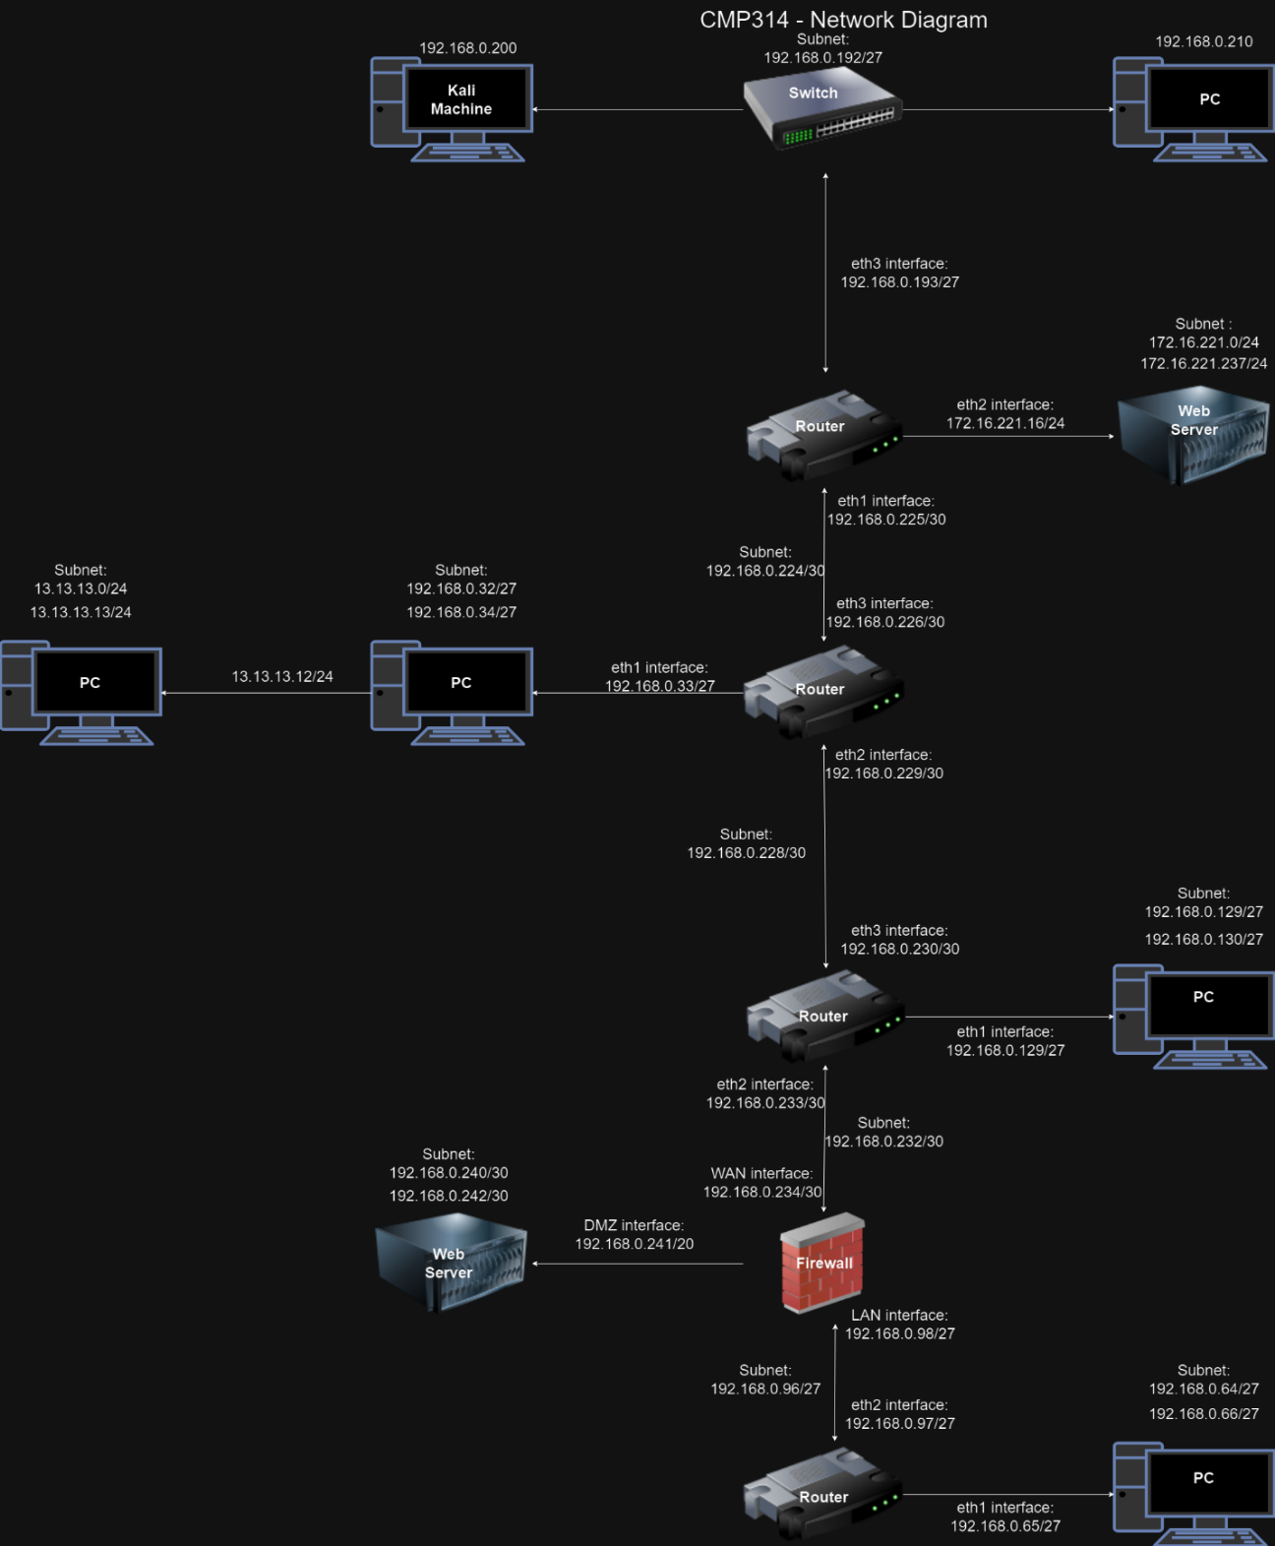

Figure 1 - Network Topology diagram showing a bus topology drawn in draw.io.

## Routing Table

Every router or firewall contains a list of “interfaces”. Interfaces in their most basic form allow for a different set of interactions between the router and the devices connected to it. The table found in Table 1 shows each interface name, subnet address & mask, IP address of the interface associated with the interface, default gateway and broadcast address. Further details on how the broadcast address can be located in Table 2 through the tester’s calculations of the subnet mask.

|  |  |  |  |  |  |  |
| --- | --- | --- | --- | --- | --- | --- |
|  | Interface | Subnet Address | Subnet Mask | IP Address | Default Gateway | Broadcast Address |
| Router | Eth1  Eth2  Eth3 | 192.168.0.224/30  172.16.221.0/24  192.168.0.192/27 | 255.255.255.252  255.255.255.0  255.255.255.224 | 192.168.0.226  172.16.221.237  192.168.0.200 | 192.168.0.225  172.16.221.16  192.168.0.193 | 192.186.0.227  172.16.221.255  192.168.0.223 |
| Router | Eth1  Pivot Eth1  Eth2  Eth3 | 192.168.0.32/27  13.13.13.13/24  192.168.0.228/30  192.168.0.224/30 | 255.255.252.224  255.255.255.0  255.255.255.252  255.255.255.252 | 192.168.0.34  13.13.13.13  192.168.0.229  192.168.0.226 | 192.168.0.33  192.168.0.33  192.168.0.229  192.168.0.226 | 192.168.0.63  13.13.13.0  192.168.0.231  192.168.0.227 |
| Router | Eth1  Eth2  Eth3 | 192.168.0.128/27  192.168.0.232/30  192.168.0.228/30 | 255.255.255.224  255.255.255.252  255.255.255.252 | 192.168.0.130  192.168.0.233  192.168.0.230 | 192.168.0.129  192.168.0.233  192.168.0.230 | 192.168.0.159  192.168.0.235  192.168.0.231 |
| Router | Eth1  Eth2 | 192.168.0.64/27  192.168.0.96/27 | 255.255.255.224  255.255.255.224 | 192.168.0.66  192.168.0.97 | 192.168.0.65  192.168.0.97 | 192.168.0.95  192.168.0.127 |
| Firewall | WAN  LAN  DMZ | 192.168.0.232/30  192.168.0.96/27  192.68.0.240/30 | 255.255.255.252  255.255.255.224  255.255.255.252 | 192.168.0.234  192.168.0.98  192.168.0.242 | 192.168.0.234  192.168.0.98  192.168.0.241 | 192.168.0.235  192.168.0.127  192.168.0.243 |

Table 1 - Routing table containing all interfaces and information related to the interfaces.

## Subnet Table

The ACME network is split up into 11 subnets, each of which have different kinds of data associated with them. This table aims to show the address, mask, host range, range of usable hosts and broadcast address.

|  |  |  |  |  |
| --- | --- | --- | --- | --- |
| Subnet Address | Subnet Mask | Host Range | Range of Usable Hosts | Broadcast Address |
| 192.168.0.224/30 | 255.255.255.252 | 192.168.0.225-192.168.0.226 | 2 | 192.168.0.227 |
| 192.168.0.228/30 | 255.255.255.252 | 192.168.0.229-192.168.0.230 | 2 | 192.168.0.231 |
| 192.168.0.232/30 | 255.255.255.252 | 192.186.0.233-192.68.0.234 | 2 | 192.168.0.235 |
| 192.168.0.96/27 | 255.255.255.224 | 192.168.0.97-192.168.0.126 | 30 | 192.168.0.127 |
| 192.168.0.192/27 | 255.255.255.224 | 192.168.0.193-192.168.0.222 | 30 | 192.168.0.223 |
| 172.16.221.0/24 | 255.255.255.0 | 172.16.221.1-172.16.221.254 | 254 | 172.16.221.255 |
| 192.168.0.32/27 | 255.255.255.224 | 192.168.0.33-192.168.0.62 | 30 | 192.168.0.63 |
| 13.13.13.0/24 | 255.255.255.0 | 13.13.13.1-13.13.13.254 | 254 | 13.13.13.255 |
| 192.168.0.128/27 | 255.255.255.224 | 192.168.0.129-192.168.0.158 | 30 | 192.168.0.159 |
| 192.168.0.240/30 | 255.255.255.252 | 192.168.0.241-192.168.0.242 | 2 | 192.168.0.243 |
| 192.168.0.64/27 | 255.255.255.224 | 192.168.0.65-192.168.0.94 | 30 | 192.168.0.95 |

Table 2 - Subnet table for the ACME network

# Networking Mapping Process

## Original Scans

The tester loaded up their Kali machine and first established the IP address for a router that would be referred to as “Router A”. The tester executed the “ifconfig” command, which displays the status of all network devices connected to the host. From the output of this command, the tester was able to determine the IP address of Router A, which was 192.168.0.200. The output from this command can be found in Figure 1.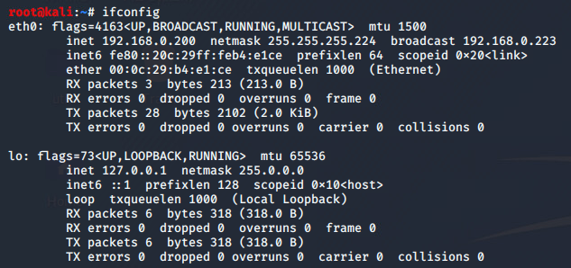

Figure 2 - ifconfig command

The tester was able to identify through the ifconfig command they Router A’s IP address was 192.168.0.200, with a subnet mask of 255.255.255.224, which indicates that there is 30 usable hosts on the subnet, and a broadcast address of 192.168.0.223. The tester then conducted another scan, including but included “/27” at the end of the IP address. This was done to search for IP addresses on the subnet that the tester had identified. The command and its output can be found in Figure 2. 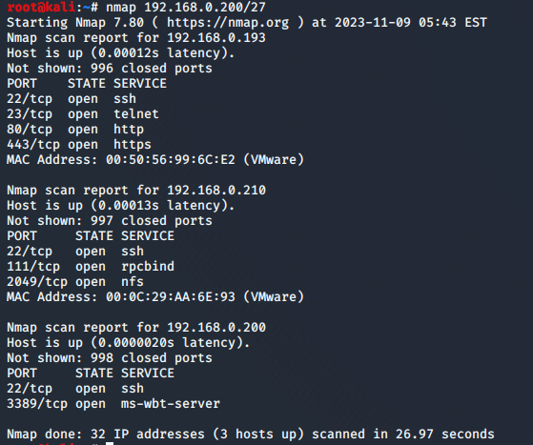

Figure 3 - Nmap scan for the original IP address, searching the /27 subnet.

From the output of this command, the tester was able to identify three separate devices operating on the same subnet. At this stage, the tester was unable to be certain of any information from the devices based on the output of this nmap scan but assumed that 192.168.0.210 may be a fileserver, due to the open NFS port, 2049. Furthermore, the tester assumed that 192.168.0.200 was a Windows server due to the open port 3389, which appeared to be running a Windows server.

Devices on a subnet must be within a pre-defined range of valid IP addresses for that subnet. The tester wanted to confirm that the subnet they had assumed for this router was accurate and therefore mapped out the available host range for a 255.255.255.224 subnet, as can be seen in Appendix 7.1. From this appendix, the tester was able to confirm that the addresses found in Figure 2 fit within a valid range, and therefore it was fair to assume that the tester would be able to run further scans against 192.168.0.192/27 which would allow them to enumerate the correct range of addresses and potentially uncover more devices operating on the same subnet.

The tester ran another nmap scan against 192.168.0.192/27 and documented their results in Figure 3.

Figure 4 - Nmap scan against 192.168.0.192/27

The tester noticed that there were not any new devices detected with their most recent command and therefore decided to start enumerating the devices that they had discovered.

## 192.168.0.193

From their original nmap scans, the tester had identified 192.168.0.193 to have four services running and decided to run an additional nmap scan to determine more information about the device. The tester ran the nmap command again and used the flag “-sCV”, which is a combination of “-sC” and “-sV”. The “-sC” flag uses default scripts when running the nmap command, and “-sV” used for grabbing any banners related to the version of the services running on the device. The tester also included the “-p-“ flag to search all 65535 ports. The testers command and output can be found in Figure 4. 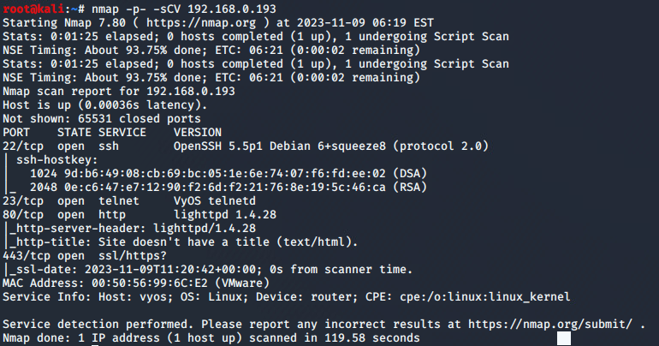

Figure 5 - Nmap scan result for 192.168.0.193

The tester looked over the output from their nmap command and although knew about port 22, 80 and 443, was unsure on the service running on port 23. After conducting some basic research, the tester noticed that “VyOS” is an open-source tool for routing and firewalls (Oevering, 2021). The tester decided to Google whether there were any default credentials for the routing software and stumbled across documentation that suggested the default credentials for VyOS software was “vyos/vyos” (OrionVM, 2023). With this information, the tester used the “telnet” command to connect to the VyOS router and attempted to use the default credentials. After entering the default credentials, the tester was successfully logged into the system. This series of events can be found in Figure 5.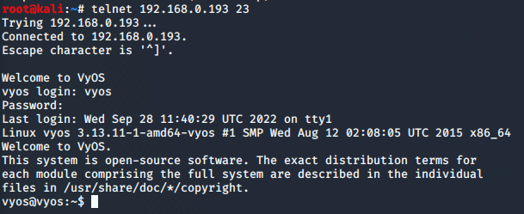

Figure 6 - 192.168.0.193 - Logging into VyOS via telnet

Once on the machine, the tester viewed the list of devices connected to the router through the use of “show interfaces”, which would allow them to identify any other devices that may not have been identified through the testers nmap scans. The output from this command can be found in Figure 6.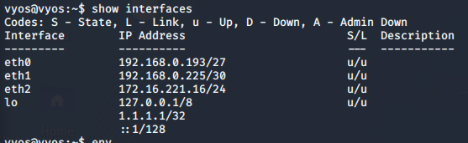

Figure 7 - Output of "show interfaces" on 192.168.0.193

The tester identified that the network interface eth0 was the network the tester had came from, eth1 was on the same network but operating under a different subnet mask and eth2 appeared to be an internal IP address. To uncover more information about the hosts, the tester followed up by using the command “show ip route”, the output of the testers command can be seen in Figure 7.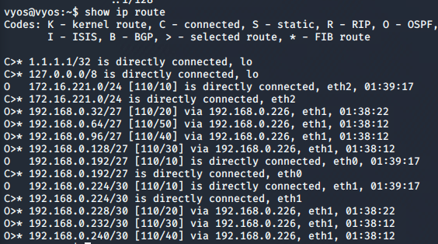

Figure 8 - Output of "show ip route" on 192.168.0.193

### 172.16.221.0/24

The tester was able to identify an IP address and subnet mask to enumerate further from the output shown above and conducted an nmap scan to uncover more information about the devices running on the devices operating on the given host range. 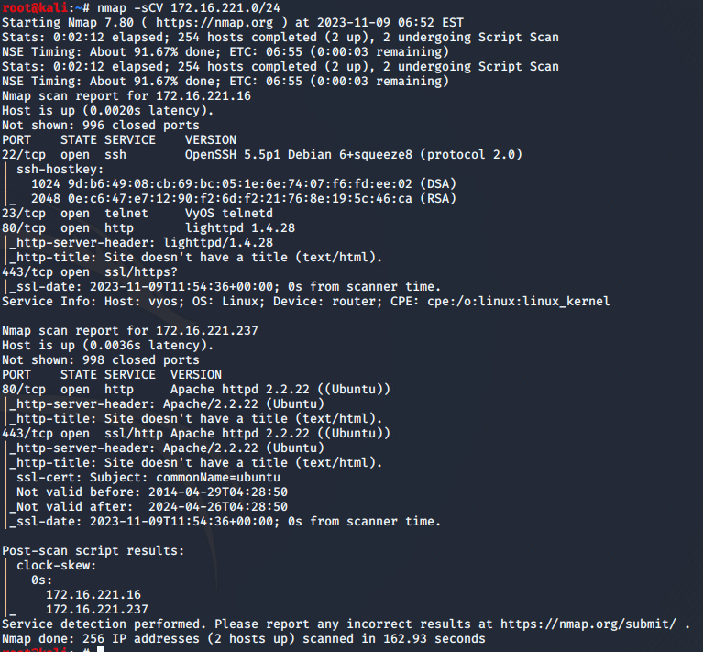

Figure 9 - Nmap scan against 172.16.221.0/24

The tester identified that 172.16.221.16 appeared to be an internal login page to manage the router from a web panel but was unsure on the contents of the HTTP server of 172.16.221.237 and decided to enumerate it further.

#### 172.16.221.237

The tester decided to run a dirbuster scan against the website to identify any directories or files that may be present on the web server. Dirbuster is a multi-threaded tool designed to bruteforce directories and filenames on a web application (Kali Linux, 2023). The tester provided the URL and then used the “common.txt” wordlist is a default wordlist that comes with the Dirbuster package. The testers command can be found in Figure 9 with the output found in Appendix 7.2.



Figure 10 - Dirb scan against 172.16.221.237

From the output found in Appendix 7.2, the tester identified one interesting directory, “/WordPress/”, which indicated the presence of a WordPress application running on the server. The tester then navigated to the WordPress directory and was greeted with an application, which had one post, titled “Hello world!”.

Figure 11 - WordPress website on 172.16.221.237

Having confirmed the presence of a WordPress instance, the tester used the tool “WPScan” with the following flags: “—url” to specify the URL where the WordPress instance was stored, “-U” to specify a username and “-P” to specify a password list to attempt to bruteforce the password for the username provided. The tester decided to use the “password.lst” wordlist and the “admin” username. The testers command can be found in Figure 11 and the output can be found in Appendix 7.3.



Figure 12 - WPScan command against 172.16.221.237

After looking at the output of the WPScan the tester had gotten a set of credentials that allowed them to log into the WordPress page. The tester then navigated to the login page and logged in. Once having logged in, the tested had proven that there were weak admin credentials for the WordPress application. The tester had also noticed that the WordPress version was 3.3.1 whilst the latest version of WordPress is 6.4.1.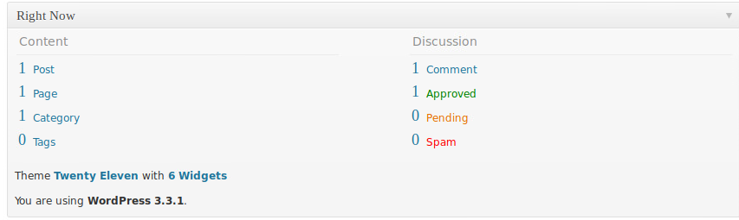

Figure 13 - Showing the version of the WordPress application running on 172.16.221.237

## 192.168.0.210

After gaining complete access of the Wordpress website on 172.16.221.237, the tester decided to enumerate the other IP they had discovered in their nmap scan of the subnet, 192.168.0.210. The device had three open ports, SSH on port 22, rpcbind on port 111 and NFS on port 2049. The tester was particularly interested in port 2049 which was NFS, more commonly known as Network File system. NFS is a protocol that, depending on the configuration, can allow a user to remotely load the contents of a file system onto their own machine. The tester began by listing any available mounts with the command *showmount* and the “-e” flag to show the list of exports.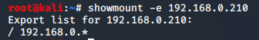

Figure 14 - Showmount command for 192.168.0.210

The tester identified from the output of this command, that they could mount any folder from any host device that was running on the network 192.168.0.*, with the asterisk indicating that any valid host could be used. The tester wanted to uncover further information about the filesystem so decided to mount the “/etc” folder of 192.168.0.210 to see if there were any login credentials stored in the passwd or shadow file.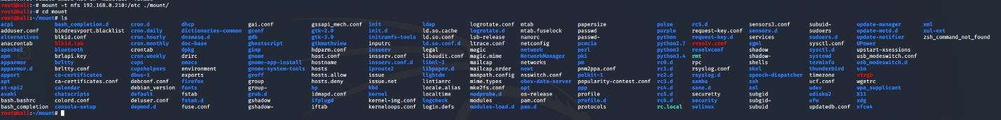

Figure 15 - Mounting /etc/ from 192.168.0.210

The tester opened the passwd and shadow files and came across a hashed password in the shadow file. Every other user in the shadow file was reserved for services besides the account “xadmin”. 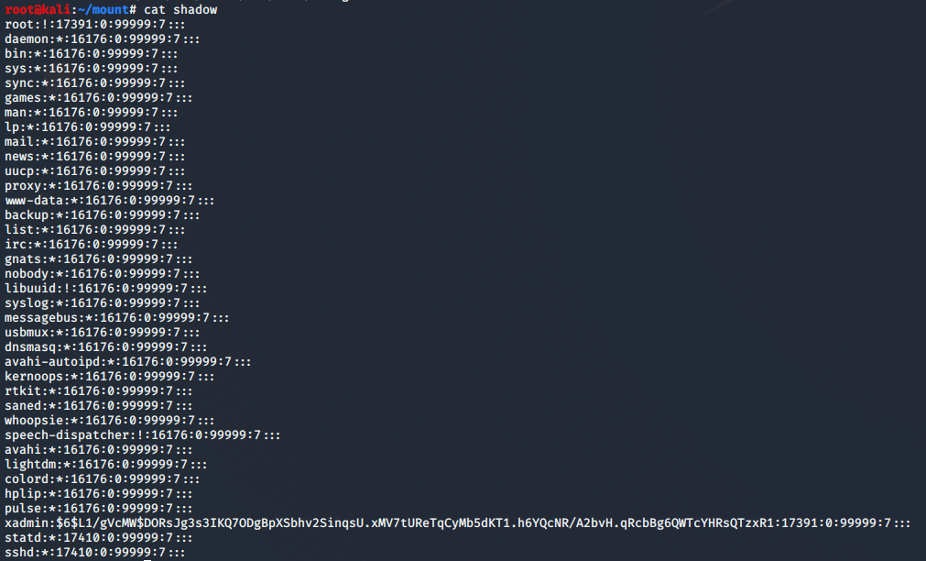

Figure 16 - Contents of /etc/shadow on 192.168.0.210

The tester copied the hash and stored it in a separate file, away from the content they had mounted, with the intentions of attempting to crack the password. Having stored the hash in a separate file, the tester used the popular password cracking library “john”. The tester specified the file that the hash was stored in and used the “—wordlist=” flag to specify the wordlist to use, in this case the tester chose the rockyou wordlist. The output from the testers command can be found in Figure 16.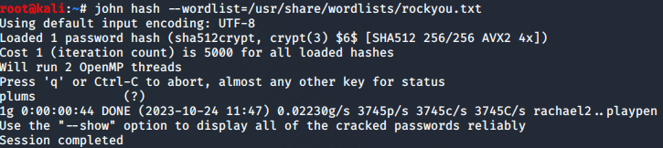

Figure 17 - Cracking a hash found from /etc/shadow on 192.168.0.210

The testers cracking attempt had found the password for the hash to be “plums”. Following this information, the tester attempted to connect to the SSH port using the credentials xadmin:plums. Once on the machine, the tester changed the interfaces connected to the machine and was connected through the same subnet that had already been identified and had no connections to any other devices. The tester also noticed that they had permissions to act as if they were the “root” user and made note of this, with the intention of going into greater detail about the risks of this later into the report.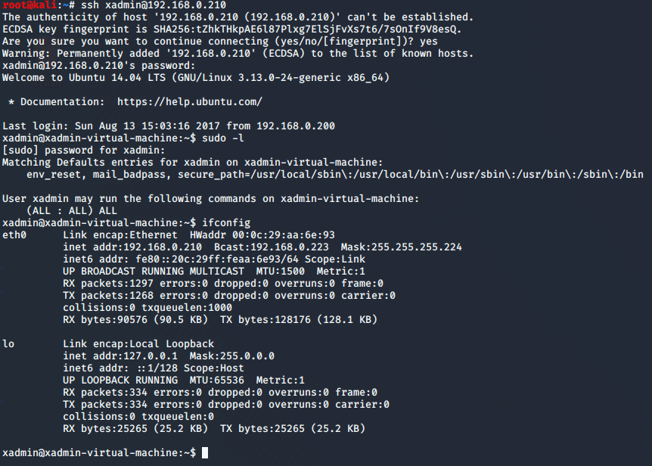

Figure 18 - Checking interfaces and permissions for xadmin on 192.168.0.210 after connecting through SSH.

## 192.168.0.226

After gaining complete control over all of the systems present from the testers original scan, the tester analysed the output of their “show ip route” command found in Figure 7 which identified the presence of a second router operating on the address 192.168.0.226. The tester was able to deduce that this was another router due to the amount of traffic that was routed through it. The tester identified that this router operating on 192.168.0.226 was operating under a /30 subnet, indicating that there were four addresses in the subnet, which meant that there could be 2 usable addresses, 192.168.0.225 and 192.168.0.226, subsequently meaning the network address must be 192.168.0.224 and the broadcast address 192.168.0.227. Knowing this information, the tester ran an nmap scan against 192.168.0.224 with the “/30” suffix to indicate the subnet, to identify what ports are open on the two IP addresses in use.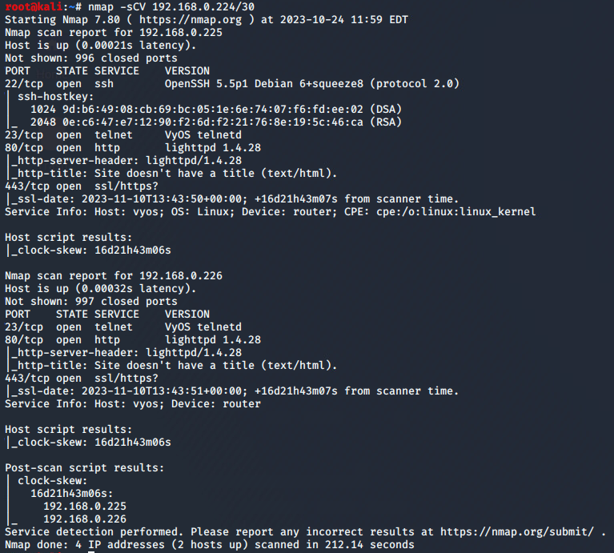

Figure 19 - Nmap scan against 192.168.0.224/30

The tester identified a VyOS telnet session running on both IP addresses and as such decided to try and reuse the credentials that they had found from earlier, on this telnet session. After attempting to log in using the same credentials, they successfully connected and as such attempted to do the same with the SSH port, and were once again, successful. Once on the VyOS router, the tester ran “show interfaces” and “show ip route” and noticed that on the network interface eth1 there was a device operating on 192.168.0.33/27.

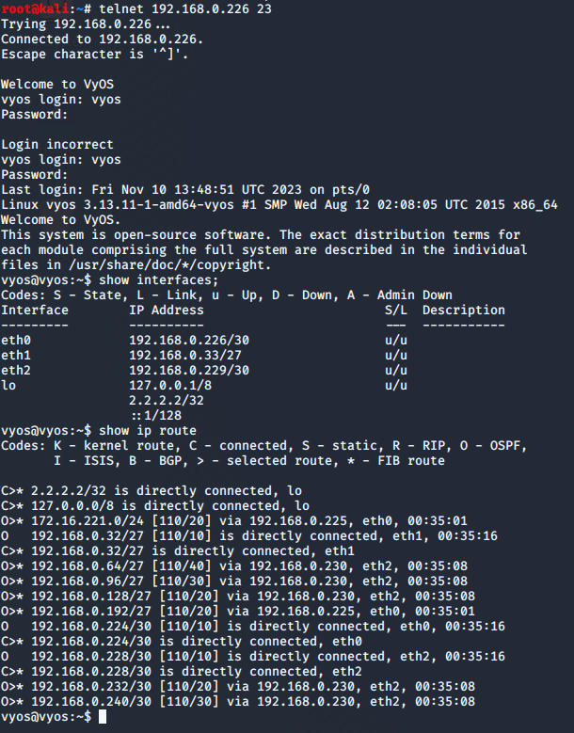

Figure 20 - "show interfaces" and "show ip route" on Router operating on 192.168.0.226

### 192.168.0.34/27

The tester ran an nmap scan against the subnet network address they had revealed from Figure 19 and noticed the presence of one other device, 192.168.0.34 which had SSH, rpcbind and NFS ports open.

The tester attempted to use the same SSH credentials they had retrieved earlier to attempt to log into the SSH server successfully logged in as the “xadmin” user. They then ran the ifconfig command and noticed a second device connected to the machine.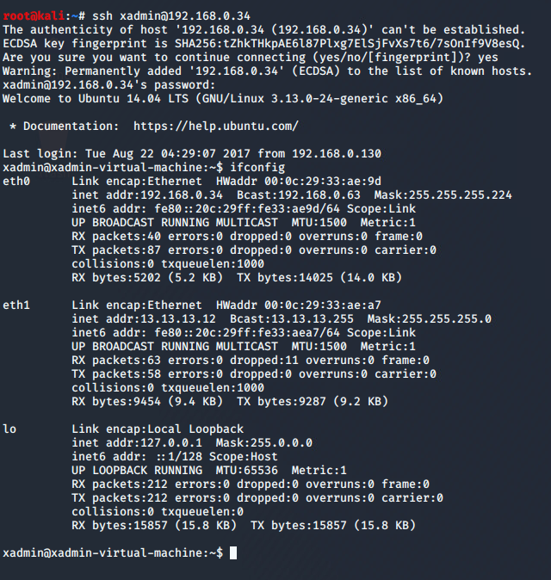

Figure 21 - Logging into SSH & ifconfig on 192.168.0.34

#### 13.13.13.13

The tested noted that through the eth1 interface a device was connected on the IP address of 13.13.13.12, which had a broadcast address of 13.13.13.255 and a subnet mask of 255.255.255.0. The tester wanted to check whether this IP address was accessible from their own Kali machine, or if it was accessible through the machine that they had SSHed into. To check this, the tester attempted to ping the IP address on both devices and noticed that it was only accessible from the machine that they had SSHed into.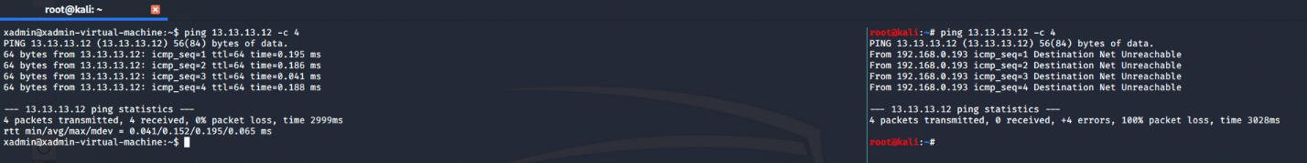

Figure 22 - Attempting to ping 13.13.13.12 from 192.168.0.34(left) & Kali Host(right)

The tester decided to check the contents of the xadmin home directory and noticed the “.bash_history” file was being updated as they were executing commands. Once opening the contents of the file, the tester noticed that the file contained the commands of someone before them, who had attempted to SSH into “13.13.13.13”.

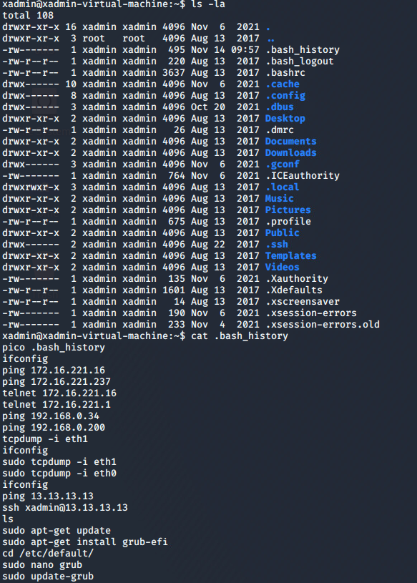

Figure 23 - Finding and opening the .bash_history file in /home/xadmin on 192.168.0.34

The tester decided to try and follow in their footsteps, attempting to log into the SSH service but was unsuccessful. As such, the tester decided that they needed to perform some pivoting, as to allow their Kali machine to access 13.13.13.13 and be able to bruteforce the admin password.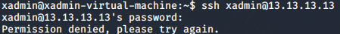

Figure 24 - Attempting to SSH into 13.13.13.13 from 192.168.0.34

To perform their pivot through the network, the tester intended to perform SSH tunnelling to allow an open SSH connection. The first step of performing SSH tunnelling is to allow it through the sshd_config file, the tester also changed the “PermitRootLogin” setting to “Yes” from “without-password”, to allow them to log in without the use of a password. The original and updated file can be found in the figures below.

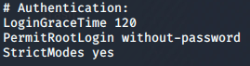

Figure 25 - Original authentication section of sshd_config

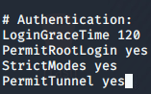

Figure 26 - SSH Tunnelling enabled version of sshd_config.

After this, the tester the tester then began the process on the machine he had compromised and his Kali machine of setting up the tunnelling. To achieve this, the tester would need to add port forwarding rules to the compromised machine and create identical interfaces for both devices so that they could communicate over the same network. The testers commands detailing this process can be found in Figure 26 The tester began by setting up an additional network interface on both devices “-w any:any”, which allows for any tunnelling interfaces to be set up on the server and client. The tester then added the IP address that they would use for the Kali machine on this interface. The tester chose 1.1.1.1 and used the “/30” subnet as they would only need 2 devices on the network. The tester then set the status of the interface to “up”, indicating that it was on and then added the network 13.13.13.13 with a /24 subnet, which was identified through Figure 20, to the network. Finally, the tester ran the ifconfig command to ensure that the interface had been set up, which it had. The tester then ran the same set of commands on the machine they had compromised. After running those commands, the tester then edited the “forwarding” file to contain “1”. This is due to the fact that the file is read as a Boolean value. If that Boolean value is “0” then port forwarding of IPV4 addresses will not be allowed, but when it is “1” it is allowed (Gasanov, 2022). Following this, the tester ran the iptables command with the flags “-t” which is used to specify the table to edit, “-A” which meant they were appending a specific rule in the testers case, “POSTROUTING”, “-s” for specifying the source, “-o” for the interface that the packets are coming from and “-j” for specifying what to do with any packets that match the rule that just been set. (HackTricks, 2023).

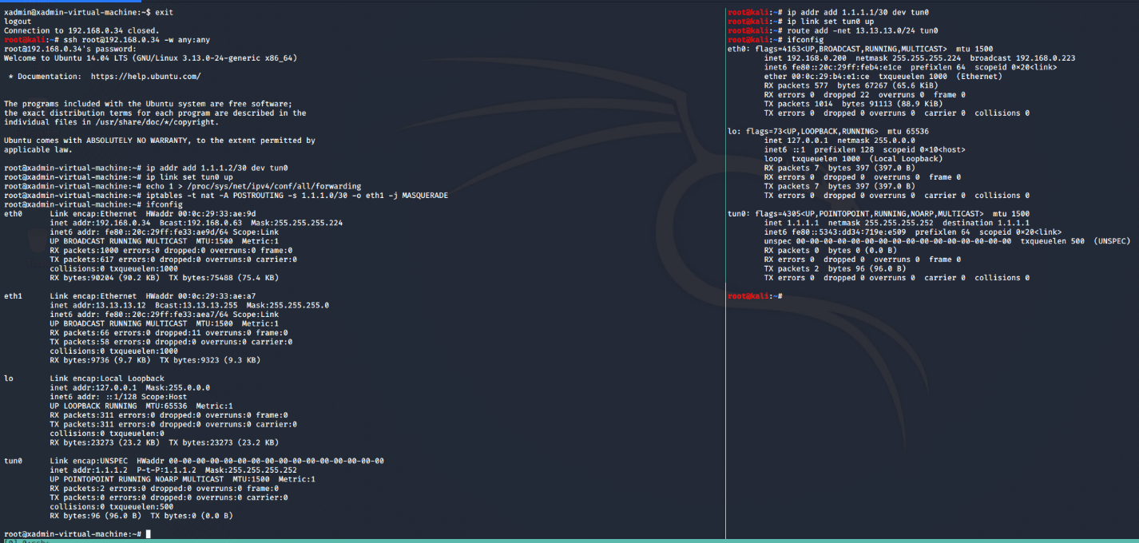

Figure 27 - Setting up SSH tunnelling for 13.13.13.13

After setting up SSH tunnelling, the tester used multiple wordlists and attempted to bruteforce the “xadmin” account password on the SSH server, eventually finding that password.lst that was provided with Metasploit contained the password for the server. The tester made use of Hydra, a popular password bruteforcing tool. The tester used the “-l” flag to specify the user to bruteforce, “-P” to specify the wordlist and then “ssh://13.13.13.13” to specify the service and IP address. The tester was given the password for the admin account, which was “!gatvol”.

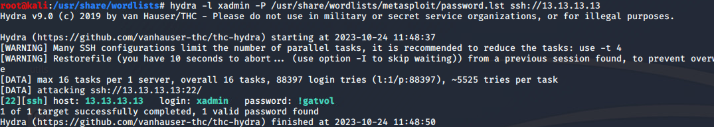

Figure 28 - Bruteforcing xadmin on 13.13.13.13

After gaining these credentials, the tester successfully logged into the SSH server and displayed the ipconfig but was not shown any new devices and therefore did not investigate any further.

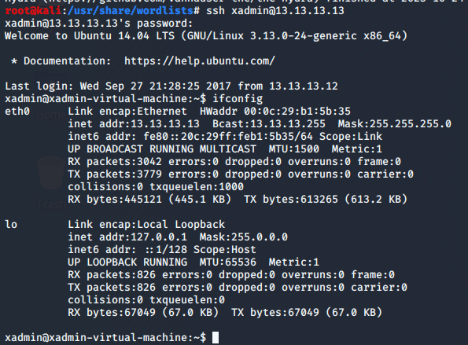

Figure 29 - Logging into 13.13.13.13 as xadmin

### 192.168.0.229/30

The tester began their enumeration by running an Nmap scan to find any hosts running on the subnet. Due to it containing the “/30”, the tester knew that there could only be a maximum of two possible hosts.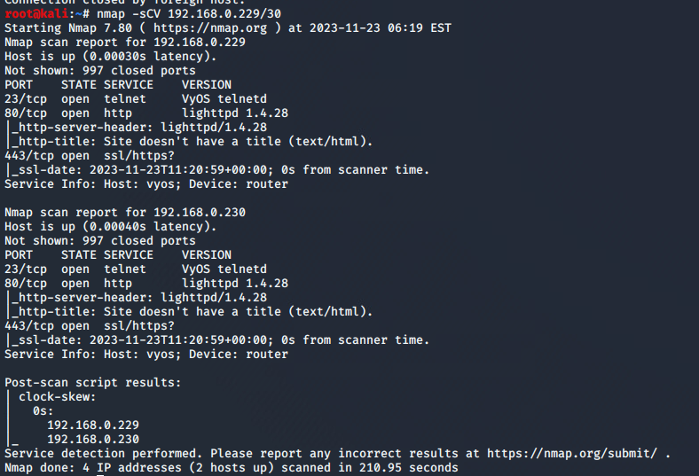

Figure 30 - Nmap scan of 192.168.0.229/30

## 192.168.0.230

The tester began by logging into the router and running the “show interfaces” and “show ip route” command to display any devices connected to the router.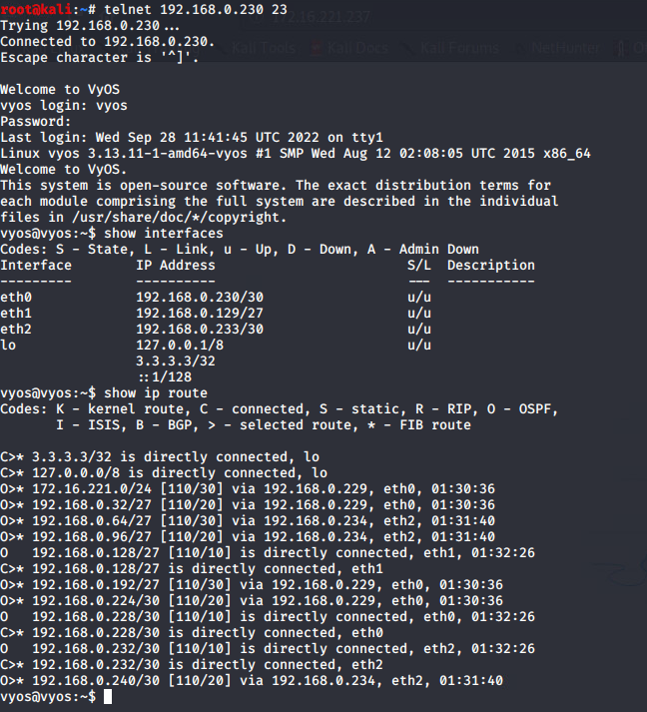

Figure 31 - "show ip route" and "show interfaces" on 192.168.0.230

### 192.168.0.128/27

The tester began by running an nmap scan against the device connected to eth1.

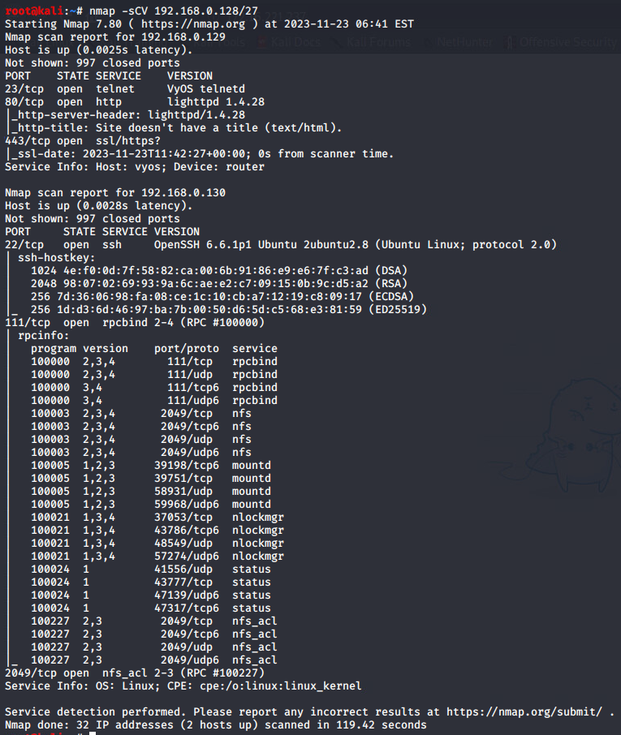

Figure 32 - Nmap scan against 192.168.0.128/27

From the output of the nmap scan, the tester identified an NFS port and thus attempted to repeat the process outlined in Figure 14 and was successful in doing so.

After having mounted the filesystem, the tester looked through the filesystem for any details that could grant them with access to the SSH server and thus looked in the “.ssh” folder and found the “authorized_keys” file which contained one entry. This confirmed to the tester that another device had connected to the PC. 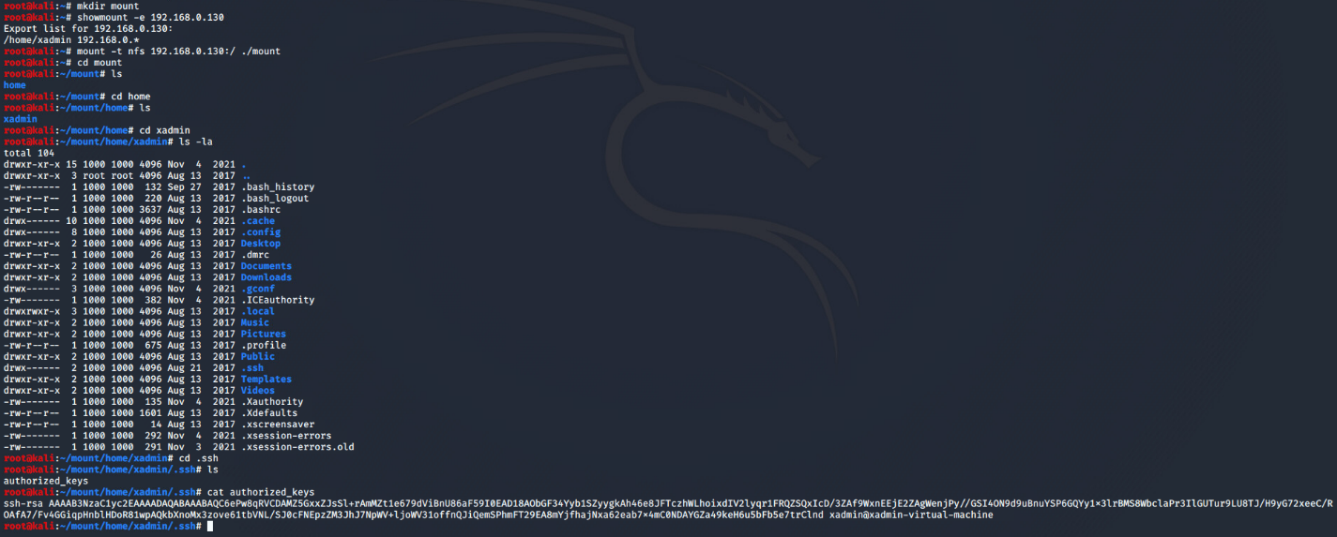

Figure 33 - Mounting NFS and opening authorized_keys on 192.168.0.130

The tester went through the devices they had previously gotten access to and attempted to connect to 192.168.0.130 until eventually one connection worked, from 192.168.0.34.

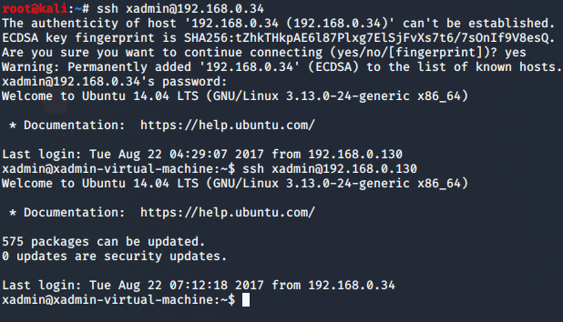

Figure 34 - Connecting to 192.168.0.130 from 192.168.0.34

### 192.168.0.240/30

After proving they could gain access to 192.168.0.130, the tester moved onto the devices connected through the network interface “eth2”. The tester started by conducting an nmap scan and analysing the results.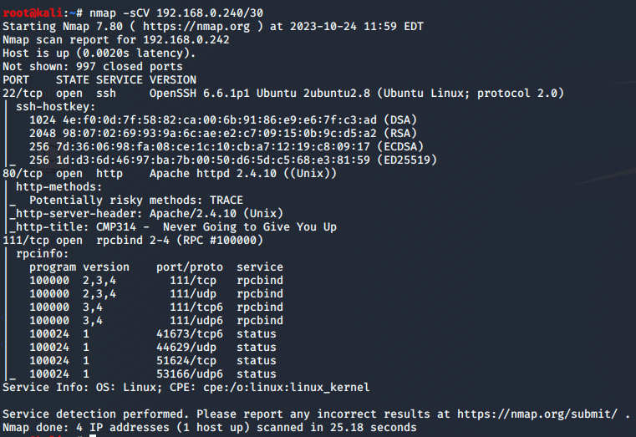

Figure 35 - Nmap scan of 192.168.0.240/30

#### 192.168.0.242

From the nmap scan, the tester confirmed the presence of a webserver running on port 80, and therefore decided to explore the webserver first.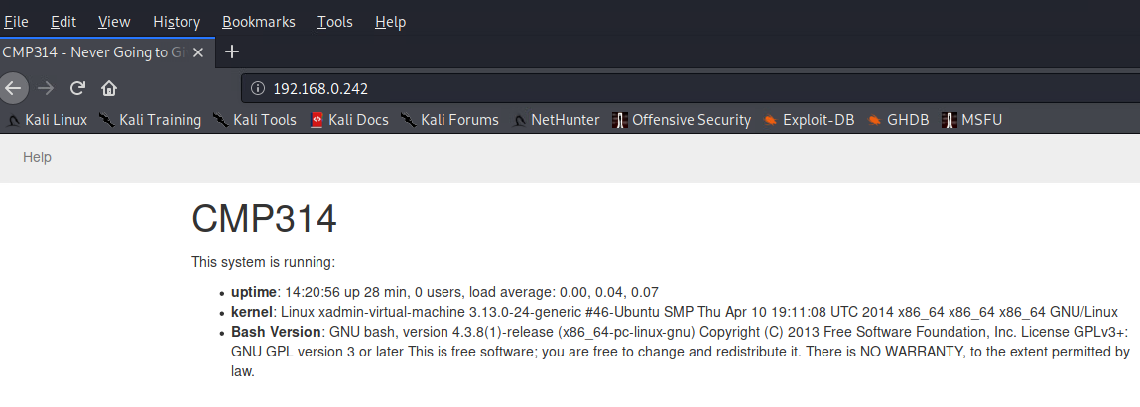

Figure 36 - Webpage contents of 192.168.0.242

The tester noticed that the webpage displayed the uptime, kernel and Bash version running on the server and ran further commands to find anything else running on the server. The tester began by running a dirbuster scan, although did not find anything worthy of pursuing.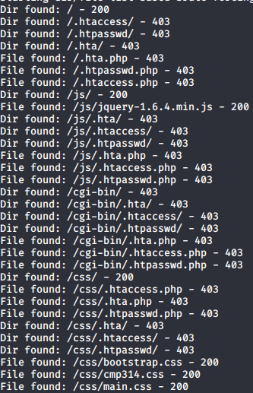

Figure 37 - Dirbuster scan against 192.168.0.242

Following this, the tester used the Nikto library and noted something interesting, that the webserver was supposedly vulnerable to CVE-2014-6271, more commonly known as “Shellshock”. 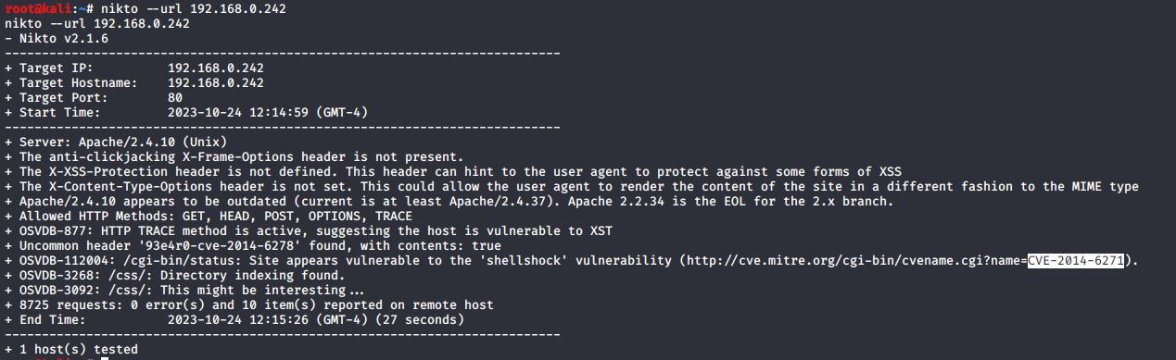

Figure 38 - Nikto scan against 192.168.0.242

The tester confirmed the vulnerability Nikto had recommended by conducting research against the installed Bash version, which they had identified from Figure 35. The shellshock vulnerability abuses an issue which allows an attacker to craft special code within an environment variable string and then executing this variable to gain code execution on the target server (FortiGuard, 2014).

The tester loaded up Metasploit and searched for “shellshock” which displayed 11 different exploits. After selecting the appropriate exploit, the tester viewed the options that they needed to configure.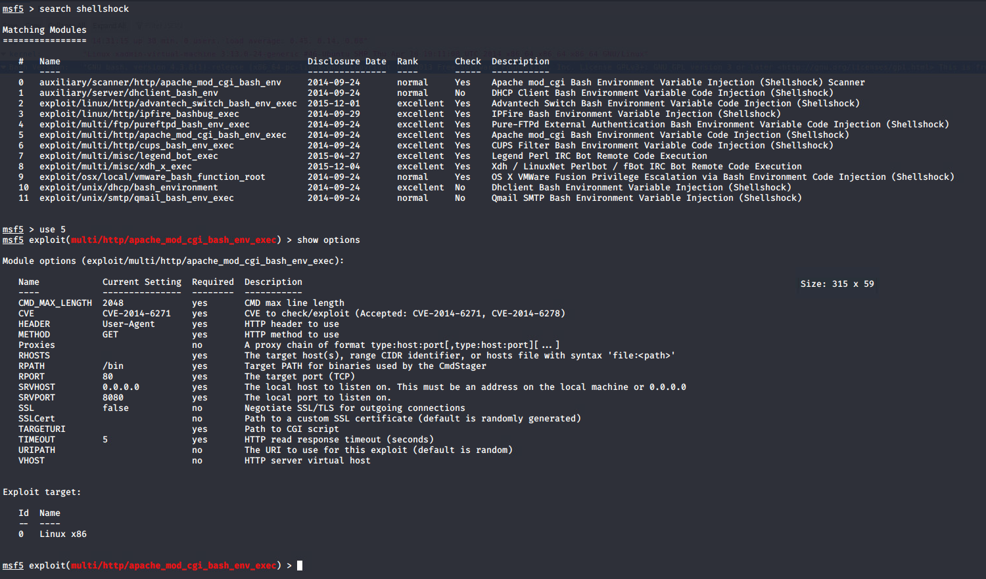

Figure 39 - Loading the shellshock exploit in Metasploit and viewing the options configuring the exploit.

The tester configured the “RHOST” option, set it to the IP address of the webserver, and then configured the “TARGETURI” setting, with the value “/cgi-bin/status”. The tester had identified through analysing the source code for the website, that the information displayed on the home page was JSON data, called from this location and therefore knew it was the place where the script was stored.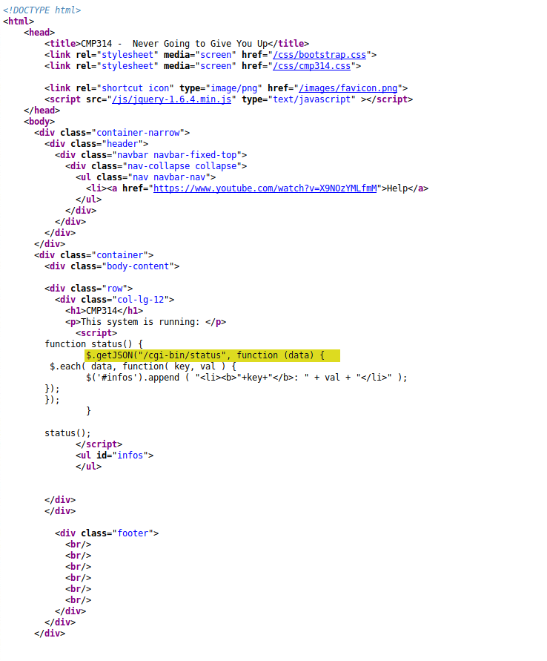

Figure 40 - Source code on 192.168.0.242:80 showing /cgi-bin/status.

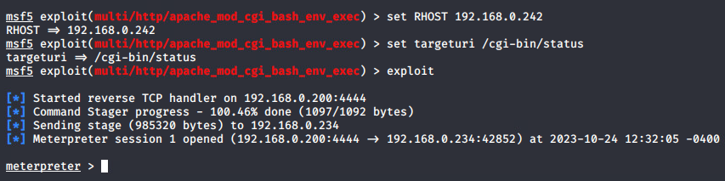

Figure 41 - Setting options for Shellshock exploit and proof of successful exploit.

The tester then utilised port forwarding to gain access to the WEBSERVER, on their local machine. The tester used the meterpreter command “portfwd add -l *PORT* -p *PORT* -r *IP*”. Where the “-l” flag represented the listening port, “-p” the port to relay traffic from and “-r” for the IP address to listen and relay from.

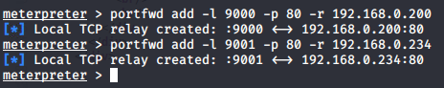

Figure 42 - Portforwarding firewall login page from 192.168.0.234

After successfully port forwarding the webserver, the tester loaded “localhost:9001” on their web browser and was greeted for a login page for “pfSense”. pfSense is an operating system designed for easy firewall configuration (Zenarmor, 2020). After searching for possible credentials, the tester stumbled across the default credentials for pfSense routers located on their own documentation which show the username as “admin” and the password as “pfsense” (pfSense, 2020). The tester attempted to log into the page and was successful.

After successfully logging into the firewall admin page, the tester was greeted with an interface that showed them three interfaces: WAN (operating on 192.168.0.234/30), LAN (operating on 192.168.0.98/27) and DMZ (operating on 192.168.0.241/30). 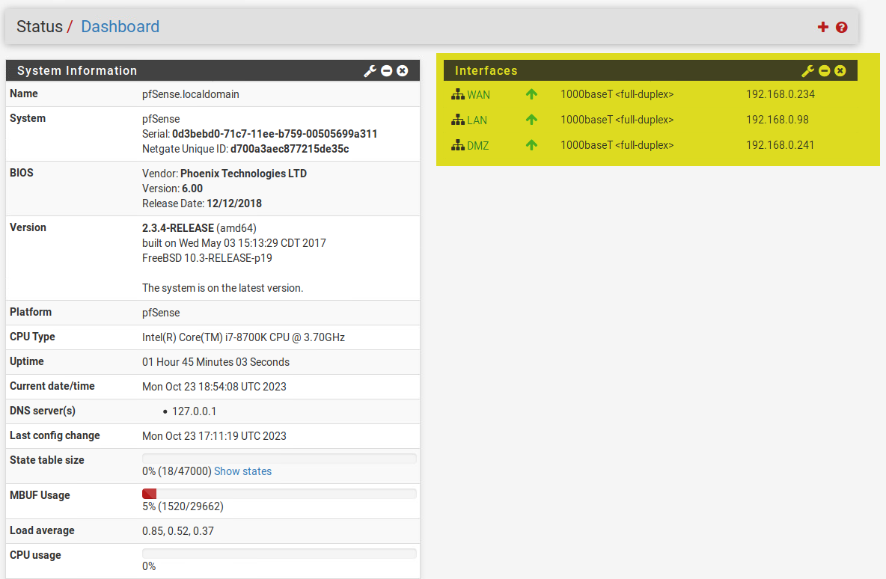

Figure 43 - Firewall home page showing three interfaces.

The tester wanted to escalate their privileges from the shell they currently had on the server and thus decided to check the “shadow” and “passwd” files on the server. The tester found two hashes in the shadow file and thus copied them over to their local machine and attempted to crack them through John the Ripper.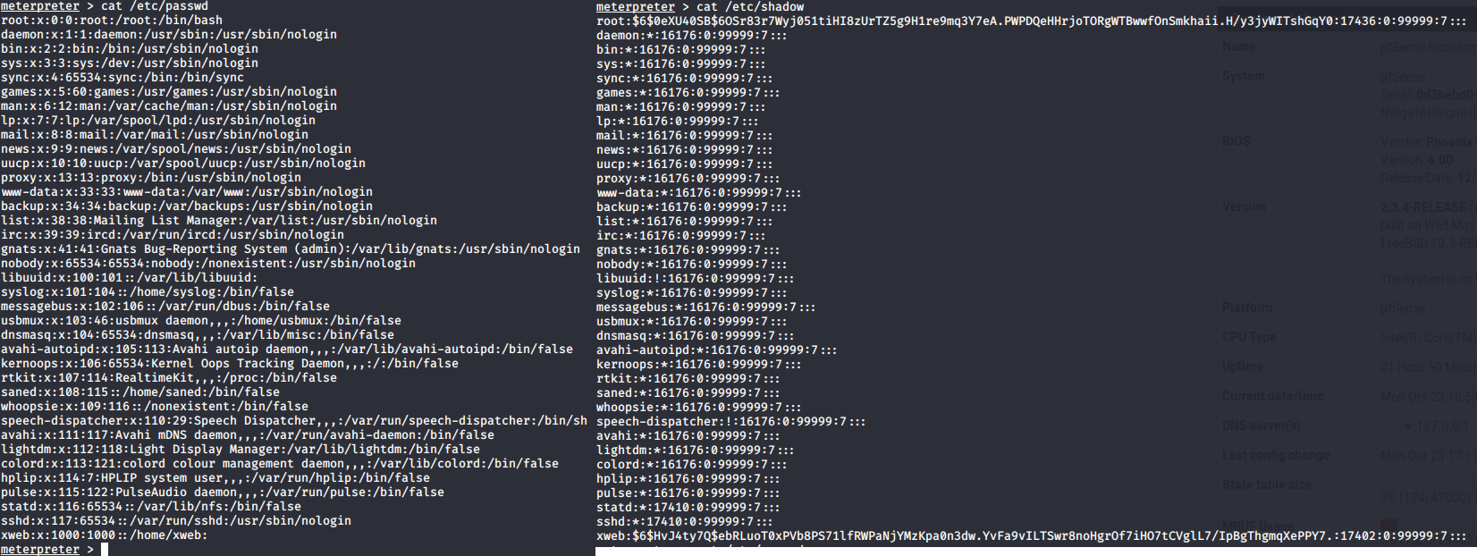

Figure 44 - Contents of /etc/shadow & /etc/passwd

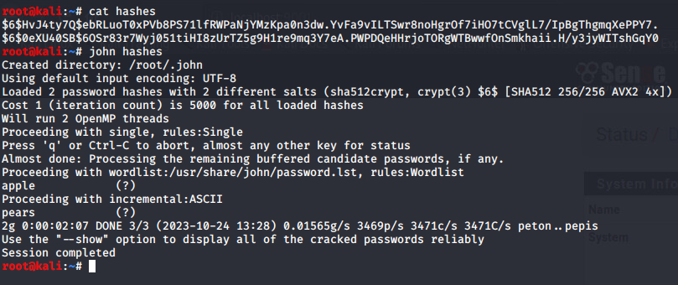

Figure 45 - Cracking "root" and "xweb" passwords

The login details revealed from this attack were root:apple and xweb:pears and as such decided to explore the other interfaces discovered.

### 192.168.0.98/27

The tester attempted to conduct an Nmap scan against the subnet but did not uncover reveal any IP addresses, which the tester knew to be wrong due to it being configured on the Firewall panel. As such, the tester navigated the Firewall admin page and loaded the “rules” section. The tester knew that the devices hidden behind the firewall would be controlled by firewall rules for the WAN. 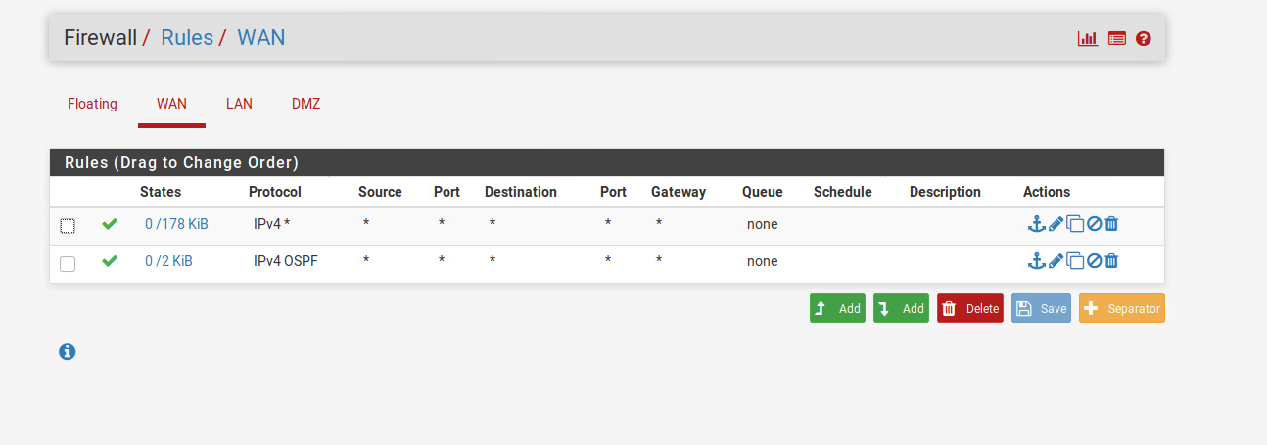

Figure 46 - Firewall rules for the WAN

The tester edited the IPv4 firewall rules and changed the destination IP address from “Single host or alias – 192.168.0.242” to “any” therefore allowing all traffic to pass through the firewall.

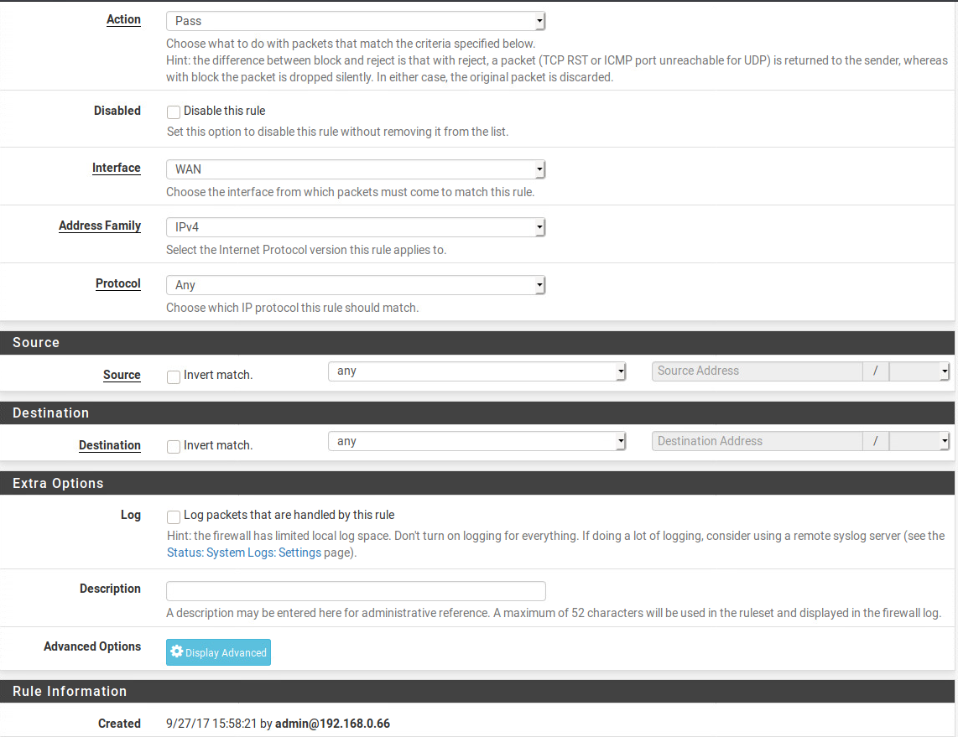

Figure 47 - Edited firewall rule settings

The tester then conducted an Nmap scan against the subnet again, this time revealing another device, running under 192.168.0.97, which appeared to be another router.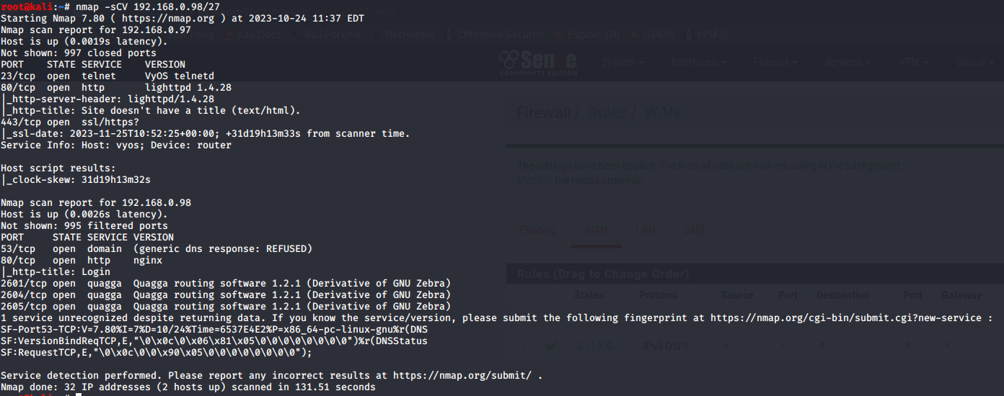

Figure 48 - Nmap scan against 192.168.0.98/27

## 192.168.0.97

The tester logged into the router and conducted the “show interfaces” and “show ip routes” command which revealed two further devices connected to the router.

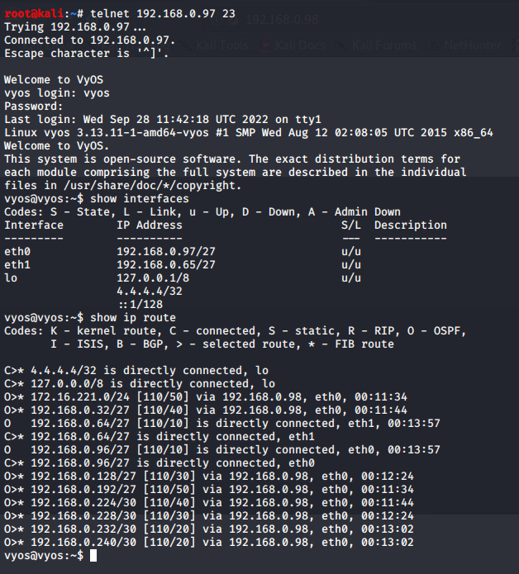

Figure 49 - show ip routes & show interfaces on 192.168.0.97

### 192.168.0.64/27

Seeing as the tester had already searched through the network on eth0, they started with the network on eth1 and conducted an nmap scan that revealed another PC with an NFS share running on 192.168.0.66.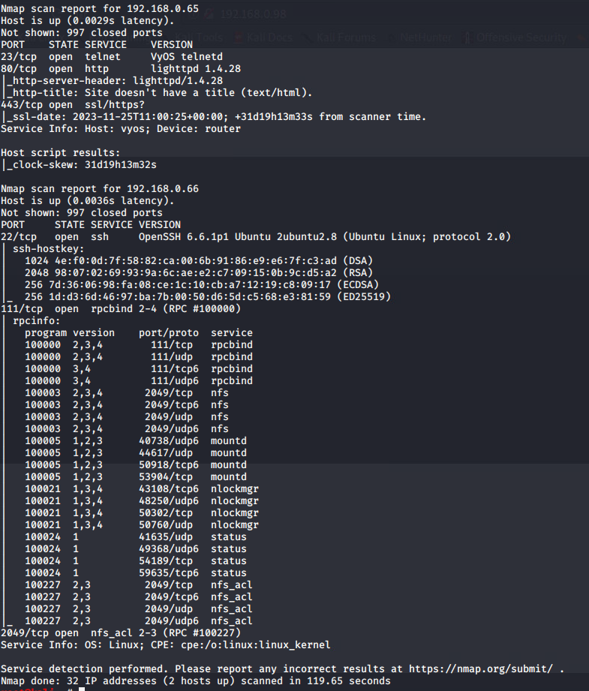

Figure 50 - Nmap scan against 192.168.0.64/27

The tester performed the same set of steps identified in Figure 14 and Figure 32 and successfully loaded the entire file system from the device.

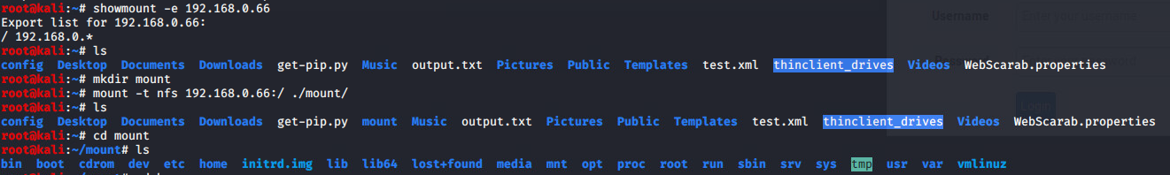

Figure 51 - Mounting 192.168.0.66 filesystem.

The tester conducted some basic enumeration of the filesystem and discovered nothing of interest, and therefore decided to attempt to log into SSH with the credentials they had uncovered earlier, although they were unsuccessful. 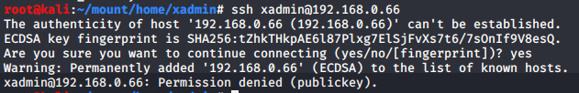

Figure 52 - Attempting to SSH into 192.168.0.66

The tester researched this error messaged and concluded that they needed to use a key to sign into the device and could not rely on a set of login credentials. The tester could achieve this by creating their own SSH key and placing it onto the filesystem they had mounted, as it would dynamically update on the server side, with any changes made by the client.

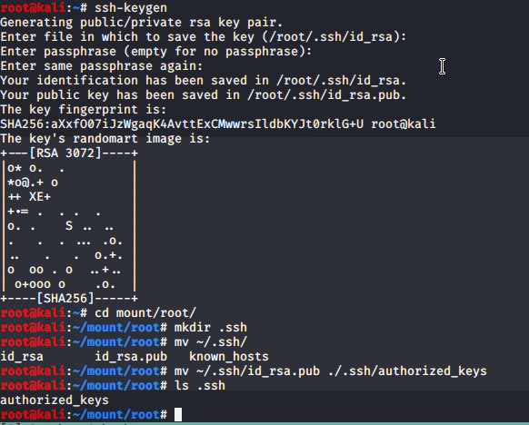

Figure 53 - Creating an SSH key and placing it onto the filesystem of 192.168.0.66

Once created, the tester attempted to log into the SSH server and was successful. Upon viewing the network configuration of the device, the tester did not find any new devices.

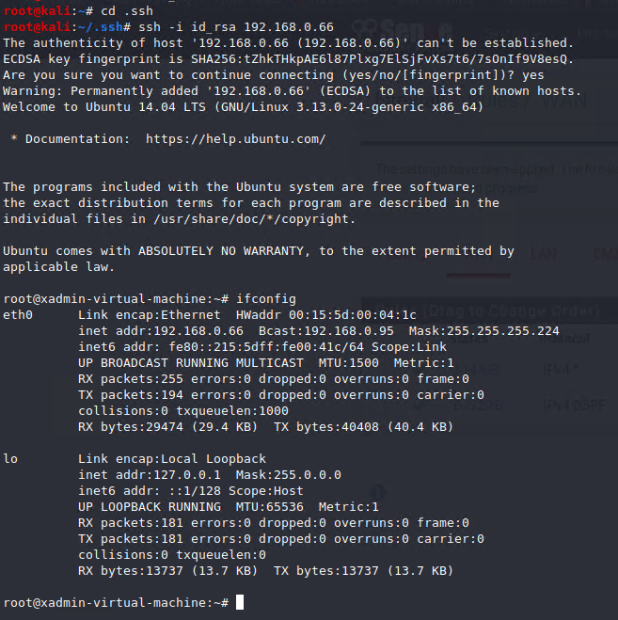

Figure 54 - Logging into 192.168.0.66 and checking ifconfig

# Security Weaknesses

## Default Passwords

Throughout the network evaluation the tester found multiple routers, and a firewall which used default credentials that are easily available online. This is an obvious security weakness as an attacker can gain access to the affected devices without any issues, therefore giving them access to the internal network and potentially allowing them to cause damage to data or services.

To solve this issue, the tester recommends changing the default username and password for these services to therefore prevent attackers from being able to log in using default credentials. The routers are hosted on a Linux based operating system and therefore can use “sudo usermod -l [old-username] [new-username]” to change the username of an account and “sudo passwd [username]” to be prompted to enter a new password.

## Lack of Password Policy

The tester uncovered multiple passwords that contained little complexity with no special characters, capitalisation or numbers. An example of these passwords could be “plums” or “pears”, both of which are basic words and are both present in multiple common wordlists, therefore the chance of these passwords being found in dictionary attacks is high. Furthermore, the password “!gatvol” shows an essence of some complexity although still appears in the default wordlist that comes with the tool, John the Ripper, and therefore should be improved on.

A password policy for all services across the network should be implemented that requires the user to make a password that meets a complex set of guidelines. Microsoft recommends the following (Microsoft, 2023):

* At least 8 characters in length
* Does not use any sequences or words found in the dictionary
* Contains lower & uppercase, numbers and symbols
* Not similar to username
* Force multi-factor authentication

## Password Reuse

Throughout the testers assessment of the network, they uncovered multiple computers were using the same password, “plums” for the SSH accounts on the individual devices. This is quite a security concern as if an attacker were to compromise a machine, one of the first passwords that they might try for compromising the same user on a different machine would be the password they had already compromised. The tester believes that, as well as the previously suggested password requirements, devices should not share the same password for any service, no matter if they are connected or not.

## Shellshock (CVE-2014-6271)

CVE-2014-6271 is a vulnerability in the Bash library between versions 1.0.3 through 4.3 that gave an attacker remote code execution on a target machine through a payload that took advantage of environment variables to execute the code (NIST, 2014). In this engagement, the tester found the vulnerability present in the /cgi-bin/status file that allowed the tester to gain access to sensitive information on the system such as account passwords for other users, and giving the tester access to the firewall administration site which was previously unavailable due to portforwarding capabilities gained from the exploit.

Protecting against this vulnerability is quite simple, considering the severity of it. At the time of writing this report, the latest version of Bash is 5.2 (GNU, 2023) and therefore the system can be upgraded through the following command “sudo apt-get update && sudo apt-get upgrade”. This will update every package on the system to the latest version, which, considering the outdated bash version, would be beneficial as it would secure the system from other possible vulnerabilities not found in this network evaluation.

## Lack of Telnet Encryption

To connect to the VyOS routers throughout this evaluation, the tester used the telnet protocol. By default, the telnet protocol is not encrypted and therefore vulnerable to attacks such as packet sniffing (Thakral, 2023). Packet sniffing attacks can lead to data leakage such as usernames and passwords.

Mitigating this issue is fairly simple, remote access to the routers should be provided through a more secure protocol such as SSH. SSH is a more secure alternative to telnet as it encrypts all traffic sent through the device, which would therefore prevent packet sniffing from being a vulnerability.

## Lack of HTTPS

Multiple important interfaces involved in the network were found to be using the HTTP protocol, which is not encrypted. Unencrypted, sensitive traffic passing through the network could allow for a malicious actor to perform a man-in-the-middle(MITM) attack and sniff this sensitive information, which could include credentials for sensitive services. An example of this could be through the pfSense software, which was responsible for controlling the firewall present in this network evaluation.

Forcing connections to this webservice to use HTTPS is relatively simple. The administrator can access the service, navigate through System > Advanced and then clicking the tickbox related to “Change to HTTPS”. The administrator can then configure the desired port, and then configure a WebGUI redirect so that all data sent on port 80 (HTTP) will not be sent, therefore forcing users to use HTTPS and preventing from sensitive data from being at risk of MITM attacks (Derelict, 2016).

## Unprotected Fileshares

Throughout the testers evaluation of the network, they uncovered multiple insecure file shares that allowed the tester to load the entire file system of multiple different devices onto their host machine and remotely edit files on the system, allowing them to alter sensitive information such as SSH keys, thus giving them unauthorised to further devices on the network effectively giving them arbitrary code execution. A remediation for this weakness could be altering the user permissions for the files that are available via NFS. This can be done on Linux machines, which are the base for the routers, through the use of *chown* and *chmod*. Both of which are commands that can be used for altering the permissions and owners for files and folders.

## Outdated Web Service Versions

The tested noticed outdated WordPress & Apache versions whilst conducting their security evaluation of the network. Outdated versions for both of these services can lead to attackers having a greater arsenal of exploits due to the lack of support for the older versions of the services.

The simplest way of mitigating this vulnerability is to ensure that any services running are updated to the latest version, therefore removing the chance of known vulnerabilities from exploited in the software.

## Lack of SSH Bruteforce Protection

Due to the configuration of the SSH services, the tester was able to utilise service bruteforce tool “Hydra” to use a wordlist to bruteforce the password for the “xadmin” user on 13.13.13.13.

A simple way of preventing future bruteforce attackers against the SSH service would be through editing the SSH config located in “/etc/ssh/sshd_config” to include “MaxTries”. MaxTries is a config variable that uses three rules to define a login “attempt”, and when MaxTries is reached, that person is then unable to sign into their account. Those conditions are:

* Validating an SSH key offered by the client
* Determining if the client can authenticate with Kerberos authentication
* Entering a password

The tester would recommend configuring this SSH setting and setting the limit to, at a maximum, three attempts. (Watson, 2022)

## Network Topology

The network operates on a bus topology, whereby the routers are in a straight line and communicate directly with one router. The disadvantage to this topology is that if an attacker were to compromise one machine in the network and take it offline, it would cause for other devices on the network to lose access to one another. For example, if the router with the eth1 interface 192.168.0.33 were to be taken offline, then the computers that are connected through the eth1 interface would be inaccessible as they would not be connected to any other devices. Although the tester is aware of the benefits to this network topology in the sense that it is easy to set up and often cheaper, the risks of the topology heavily outweigh these benefits.

The tester would recommend the implementation of a different network topology such as a ring topology. The benefits of a ring topology are that if a device were taken offline the only devices affected would be the ones directly connected to it, as the other devices in the topology would be able to access every other device by following the other direction of the ring. This topology does also have its disadvantages. An example ring topology can be found in Figure 54. Assuming “Server A” were to go down, “Server F” would have to send any packets for “Server B” through server E, D and C, which would increase the time it would take for data to reach the host. This is a potential disadvantage of this topology as it can cause for network delays if there is large amounts of traffic having to be sent from one side of the topology to the other. This being said, the benefits of this topology in terms of security and usability outweigh the disadvantage of increased network traffic.

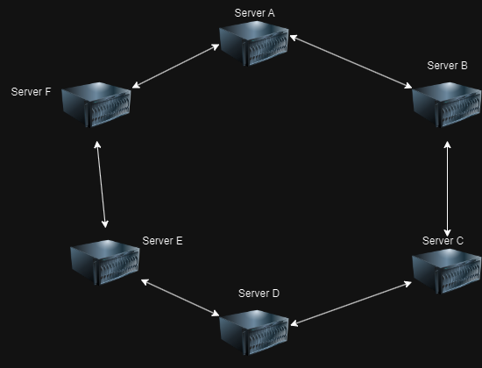

Figure 55 - Example ring topology drawn on draw.io

# Network Design Critical Evaluation

As mentioned throughout this report, the tester has made countless suggestions to improve the ACME network. The tester believes that the first improvement that should be made to the network is the security of every single device running on the network, with each service being individually reviewed for misconfigurations, outdated software, unencrypted services and password policies.

Throughout the network, the tester uncovered routers, firewalls and SSH connections which used the default credentials which can be found through online documentation and therefore can be used by anyone. The tester recommends changing these default passwords to meet a criteria that would remove any kind of bruteforce or dictionary attacks from being possible against any of the devices on the network. As well as default credentials, the tester found multiple simple passwords which are present in wordlists that are distributed with common hacking tools such as “pears” and “!gatvol”. It is recommended that these passwords be changed and brought up to the level enforced by the password policy recommended in Section 4.3.

Furthermore, the tester uncovered multiple devices running the “telnet” service, which is notorious for its lack of encryption. Due to the telnet service being used for logging into routers, sensitive information such as administrative credentials are transferred over the service and can be at risk of an attacker performing a MITM attack and gaining these credentials as they are sent across the service. It is recommended that the telnet service be removed on all routers and for connection to the router to be forced through an encrypted alternative such as SSH. This also applies for the web servers present throughout the network, as they utilise the HTTP protocol instead of HTTPS.

Finally, as previously recommended, the tester would advise that the network topology for the ACME network be changed. Due to its current topology, if one router were to be taken down by an attacker then it would cause for the network to face major issues, as any device either side of the router taken down would not be able to communicate with anything on the other side of the router. The tester has gone into greater detail regarding a replacement topology in Section 4.10.

# Conclusions

In conclusion, through the tester’s evaluation of the ACME network, multiple issues have been discovered with the current network which require addressing immediately. The network has countless vulnerabilities which would allow for an attacker to compromise and take down any device on the network with little, if any, restrictions. Once a replacement network administrator has been hired, it is heavily recommended that they utilise the mitigations mentioned throughout this document to provide an understanding of the weaknesses within the network, and allow the network administrator to perform their own evaluation and then implement changes to improve the overall security of the ACME network.

# Bibliography

Derelict, 2016. *How to change login from HTTP to HTTPS?.* [Online]   
Available at: https://forum.netgate.com/topic/107806/how-to-change-login-from-http-to-https/2  
[Accessed 3 December 2023].

Derobert, 2013. *StackExchange.* [Online]   
Available at: https://unix.stackexchange.com/questions/86720/can-i-create-a-virtual-ethernet-interface-named-eth0

FortiGuard, 2014. *Remote Exploit Vulnerability in Bash - (Shellshock).* [Online]   
Available at: https://www.fortiguard.com/psirt/FG-IR-14-030  
[Accessed 24 November 2023].

Gasanov, A., 2022. *Stack Exhange.* [Online]   
Available at: https://unix.stackexchange.com/questions/723977/difference-between-net-ipv4-conf-all-forwarding-and-net-ipv4-ip-forward

GNU, 2023. *index: bash.git.* [Online]   
Available at: http://git.savannah.gnu.org/cgit/bash.git/log/  
[Accessed 3 December 2023].

HackTricks, 2023. *HackTricks.* [Online]   
Available at: https://book.hacktricks.xyz/generic-methodologies-and-resources/tunneling-and-port-forwarding#vpn-tunnel

Kali Linux, 2023. *Kali Linux.* [Online]   
Available at: https://www.kali.org/tools/dirbuster/

Kerrisk, M., 2023. *Manual.* [Online]   
Available at: https://man7.org/linux/man-pages/man8/iptables.8.html

Microsoft, 2023. *Password policy recommendations for Microsoft 365 passwords.* [Online]   
Available at: https://terranovasecurity.com/blog/how-to-create-a-strong-password-in-7-easy-steps/  
[Accessed 28 November 2023].

NIST, 2014. *CVE-2014-6271 Detail.* [Online]   
Available at: https://nvd.nist.gov/vuln/detail/cve-2014-6271  
[Accessed 3 December 2023].

Oevering, B., 2021. *Bart Oevering.* [Online]   
Available at: https://www.bartoevering.nl/tech/vyos/vyos-what-is-vyos-and-why-i-want-to-use-vyos/

OrionVM, 2023. *OrionVM Docs.* [Online]   
Available at: https://docs.orionvm.com/vyos/getting-started/#:~:text=The%20default%20username%20for%20VyOS,the%20default%20password%20is%20vyos%20.

pfSense, 2020. *Default Username and Password.* [Online]   
Available at: https://docs.netgate.com/pfsense/en/latest/usermanager/defaults.html  
[Accessed 24 November 2023].

Thakral, K., 2023. *Differences between SSH & Telnet.* [Online]   
Available at: https://www.geeksforgeeks.org/difference-ssh-telnet/  
[Accessed 28 November 2023].

Watson, R., 2022. *SSH Hardening Tips to Prevent Brute-Force Attacks.* [Online]   
Available at: https://goteleport.com/blog/ssh-hardening-to-prevent-brute-force-attacks/  
[Accessed 3 December 2023].

Zenarmor, 2020. *What is pfSense® software?.* [Online]   
Available at: https://www.pfsense.org  
[Accessed 24 November 2023].

# Appendices

## Subnet Table Calculations

The table below shows basic calculations for identifying how many host IP addresses are available and therefore the appropriate subnet prefix and therefore the appropriate subnet address.

### Subnet Calculations

|  |  |  |  |  |  |  |  |  |  |
| --- | --- | --- | --- | --- | --- | --- | --- | --- | --- |
| Subnet | 1 | 2 | 4 | 8 | 16 | 32 | 64 | 128 | 256 |
| Host | 256 | 128 | 64 | 32 | 16 | 8 | 4 | 2 | 1 |
| Subnet Mask | /24 | /25 | /26 | /27 | /28 | /29 | /30 | /31 | /32 |

The table under 7.1.2 shows the subnet calculations for any IP range operating on the “/24” or 255.255.255.0 subnet mask range.

### 13.13.13.0/24 & 172.16.221.0/24

|  |  |  |  |  |  |  |
| --- | --- | --- | --- | --- | --- | --- |
| Device IP | Subnet Mask | Host IP Range | Range of Usable Hosts | | Broadcast Address | Binary Representation |
| 13.13.13.0 | /24 | 13.13.13.1-13.13.13.254 | 254 | 13.13.13.255 | | 11111111.11111111.11111111.00000000 |
| 172.16.221.0 | /24 | 17.116.221.1-172.16.221.254 | 254 | 172.16.221.255 | | 11111111.11111111.11111111.00000000 |

The table under 7.1.3 shows the subnet calculations for any IP addresses operating on the “/27” or 255.255.255.224 subnet mask range.

### 192.168.0.*/27

|  |  |  |  |  |  |
| --- | --- | --- | --- | --- | --- |
| Device IP | Subnet Mask | Host IP Range | Range of Usable Hosts | Broadcast Address | Binary Representation |
| 192.168.0.32 | /27 | 192.168.0.33-192.168.0.62 | 30 | 192.168.0.63 | 11111111.11111111.11111111.11100000 |
| 192.168.0.64 | /27 | 192.168.0.65-192.168.0.94 | 30 | 192.168.0.95 | 11111111.11111111.11111111.11100000 |
| 192.168.0.96 | /27 | 192.168.0.97-192.168.0.126 | 30 | 192.168.0.127 | 11111111.11111111.11111111.11100000 |
| 192.168.0.128 | /27 | 192.168.0.129-192.168.0.158 | 30 | 192.168.0.159 | 11111111.11111111.11111111.11100000 |
| 192.168.0.192 | /27 | 192.168.0.193-192.168.0.222 | 30 | 192.168.0.223 | 11111111.11111111.11111111.11100000 |

The table under 7.1.4 shows the subnet calculations for any IP addresses operating under the “/30” or 255.255.255.252 subnet mask range.

### 192.168.0.*/30

|  |  |  |  |  |  |
| --- | --- | --- | --- | --- | --- |
| Device IP | Subnet Mask | Host IP Range | Range of Usable Hosts | Broadcast Address | Binary Representation |
| 192.168.0.224 | /30 | 192.168.0.225-192.168.0.226 | 2 | 192.168.0.227 | 11111111.11111111.11111111.11111100 |
| 192.168.0.228 | /30 | 192.168.0.229-192.168.0.230 | 2 | 192.168.0.231 | 11111111.11111111.11111111.11111100 |
| 192.168.0.232 | /30 | 192.168.0.233-192.168.0.234 | 2 | 192.168.0.235 | 11111111.11111111.11111111.11111100 |
| 192.168.0.240 | /30 | 192.168.0.241-192.168.0.242 | 2 | 192.168.0.243 | 11111111.11111111.11111111.11111100 |

## Valid Host Range for the 255.255.255.224 subnet

|  |  |  |
| --- | --- | --- |
| **IP Address** | **Usable Address Range** | **Broadcast Address** |
| 192.168.0.0 | 192.168.0.1-192.168.0.30 | 192.168.0.31 |
| 192.168.0.32 | 192.168.0.33-192.168.0.62 | 192.168.0.63 |
| 192.168.0.64 | 192.168.0.65-192.168.0.94 | 192.168.0.95 |
| 192.168.0.96 | 192.168.0.97-192.168.0.126 | 192.168.0.127 |
| 192.168.0.128 | 192.168.0.129-192.168.0.158 | 192.168.0.159 |
| 192.168.0.160 | 192.168.0.161-192.168.0.190 | 192.168.0.191 |
| 192.168.0.192 | 192.168.0.193-192.168.0.222 | 192.168.0.223 |
| 192.168.0.224 | 192.168.0.225-192.168.0.254 | 192.168.0.255 |

## Dirb Output for 172.16.221.237

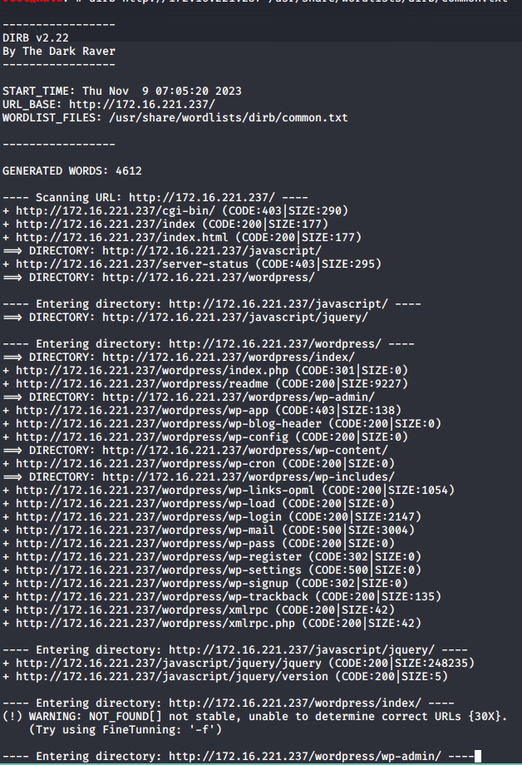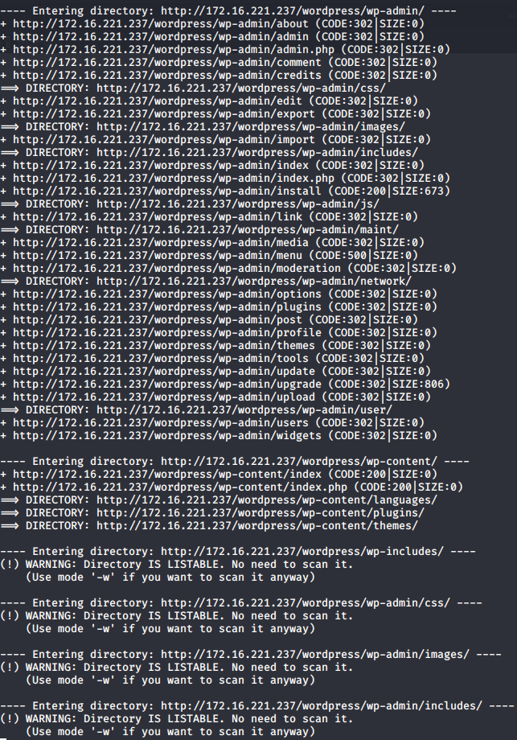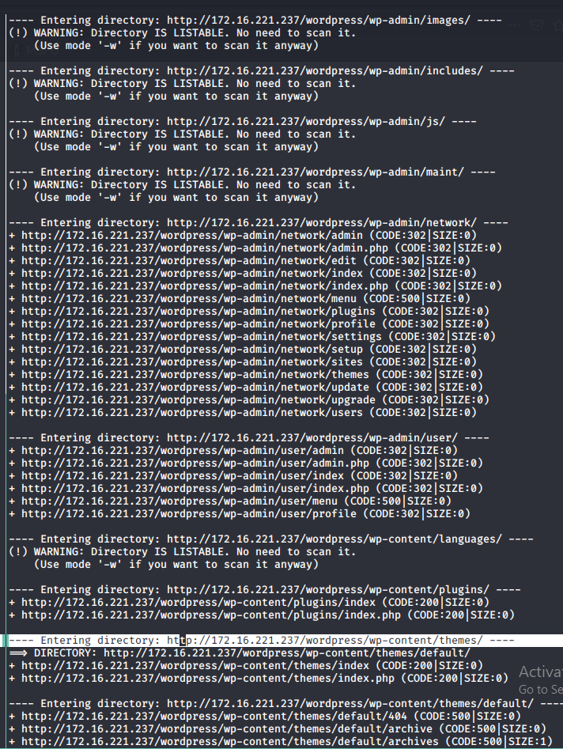

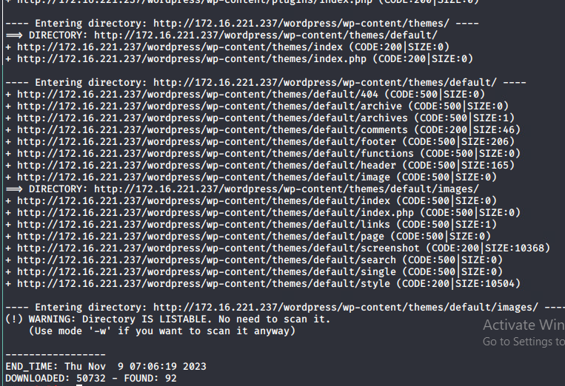

## WPScan Output for 172.16.221.237

